3.a Pole and zero location can be decided by frequency, s = jw, w= 2pi\*f, but I’m confused how to set it in Simulink, not familiar with it.

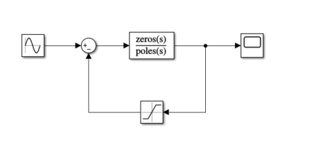

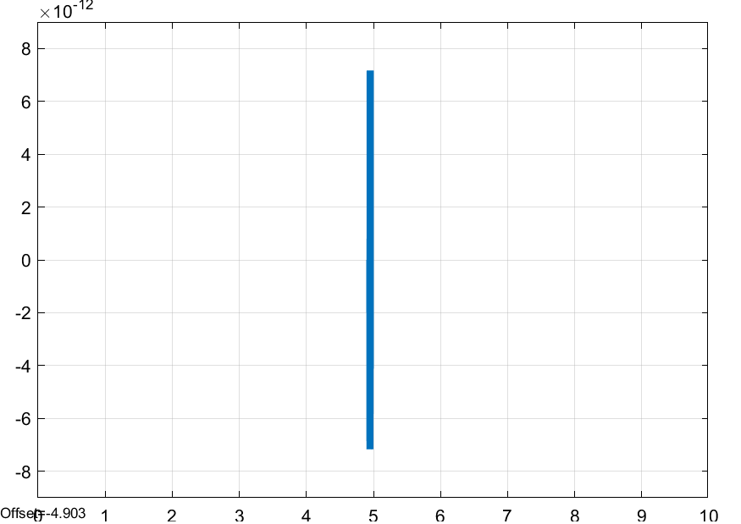

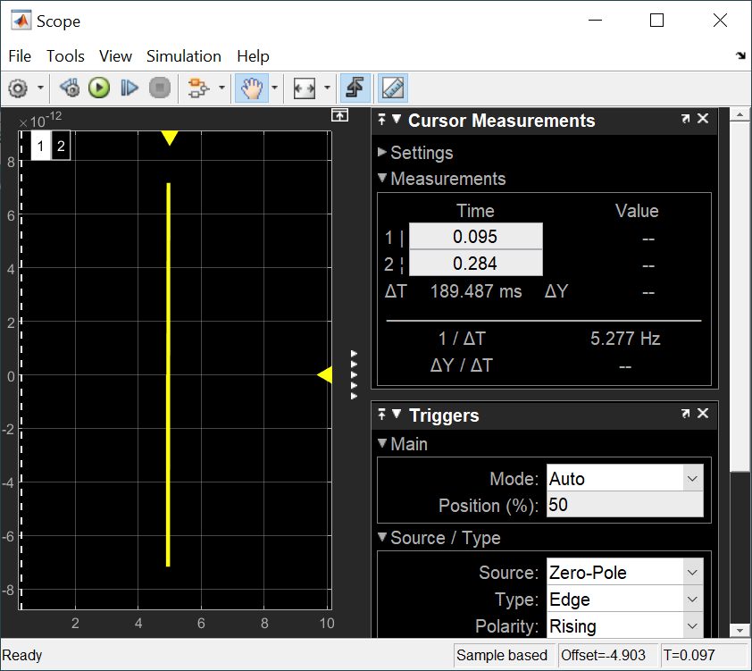

3.b has to figure out how to correctly measure frequency in scope,

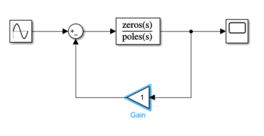

Again this should be based on correctly set pole locations in (a).

